Introduction

As part of my FETAC Level 5 Spreadsheet Methods module, I was was required to setup a spreadhseet for a retail outlet that sells electronics. I have designed my spreadsheet for Vision Electronics. The spreadsheet will track wages and sales for 12 employees, some of whom work on a part time basis. This spreadsheet will include the hourly rate, hours worked, sales, bonuses (which will be given for employees who sell 18 or more products (€22 bonus) and employees who sell below 18, with the cut off starting at 10 products (for a €10 bonus). Deductions will include 20% tax. It will also show the maximum, minimum and average of all sales.

Overview of Company details and aims

Vision Electronics is located on the middle floor of Stephen's Green Shopping Centre. The company has been up and running since March of 2012. Vision Electronics currently employees 12 people, some of which work part time (and the occasional drop in worker). Each employees store ID shows their name, as well as a working code labelled “A” (Full Time), “B” (Part Time) and “C” (Drop In), hours worked in the week and their overall sales of electronics for the week. Full Time workers are on higher rates of pay than Part Time and Drop In workers. Part Time workers currently have the lowest rate of pay. The owner of Vision Electronics has asked for me to design a spreadsheet for the store, which is simple to use and will also be easy to show the amount of sales an employee has made, as well as their wages.
The spreadsheet will aim to;
- Show the hourly rate for each employee
- Show the number of sales made by the employees
- Show the deductions from each of the employees’ wages
- Show which employee gets a bonus and which employees do not
- Calculate the net income for each employee

List of Specific Problems and Solutions
the maximum

Input and Output Data Identified

Input data

Output data

Data Processing
Layout of spread sheet detailing all aspects of the design
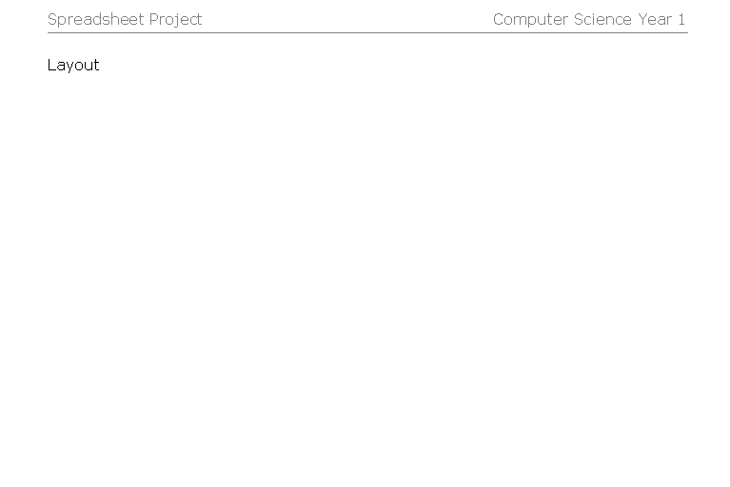

Header

Font = ?

Layout was decided because ?

Footer
Production and Implementation
(printouts of your spreadsheet)

Two sets of printouts must be used one is the original and the other shows what happens when a value is changed. Please do not forget to do this.
Evaluation

Explain things that were successful and difficulties that you overcame (details) .
Modifications to improve the spreadsheet

